**Project Deliverable 3 – User Manual**

**Faculty Name:** Information Technology

**Module Code:** ITECA3-B12

**Module Name:** Web Development and e-Commerce

**Content Writer:** Kariboba Mpwampu

**Copy Editor:** Mr Kyle Keens

**Submission Date:** Block 2 Week 5

|  |  |
| --- | --- |
| **Student Name** | Ryan Kok |
| **Student Number** | QB8J66C71 |
| **Project Title** | Ordering Website for Greg’s Bakery |
| **Submission Date** | 14/06/2023 |

**Table of Contents**

3.1 Introduction 3

3.2 Basics: Accessing your website and Admin 3

3.3 Products: Adding, removing, and updating products 4

3.4 The front page: adding and changing images 4

3.5 Orders 5

3.6 Updating a page on your site 5

# Introduction

**3.1.1 Background**

Greg’s Bakery is a family bakery based in Durbanville. They are concerned with the decline in sales they have been experiencing over the past few years. The wanted a website built in order to engage with the public more and also host an online ordering service.

**3.1.2 About this website**

The website was all built using custom code. Using a combination of HTML, CSS, JavaScript and PHP, we were able to construct a digital storefront, allowing customers to place orders, which they can then go pickup in store. HTML and CSS are used to change how the website looks. JavaScript is used implement the dynamic aspects of the app.

The website was hosted using a service called Infinity Free, which is a free, online tool that is able to host websites. You can host websites built using website building tools, but for this case is was hosted using complete custom code.

# Basics: Accessing your website and Admin

**3.2.1 Accessing the website**

The general user will access using the link: <http://gregsbakery.000.pe/?i=1>. This is the link that will show up in a Google search for the website. This link should also be shared via social media platforms, such as Facebook or Twitter.

The admins will be able to access admin features by logging into the Infinity Free account created for this website. The login credentials will be shared with the bakery owners.

**3.2.2 The Admin Area**

phpMyAdmin is the tool that is used to access the admin features of the website.

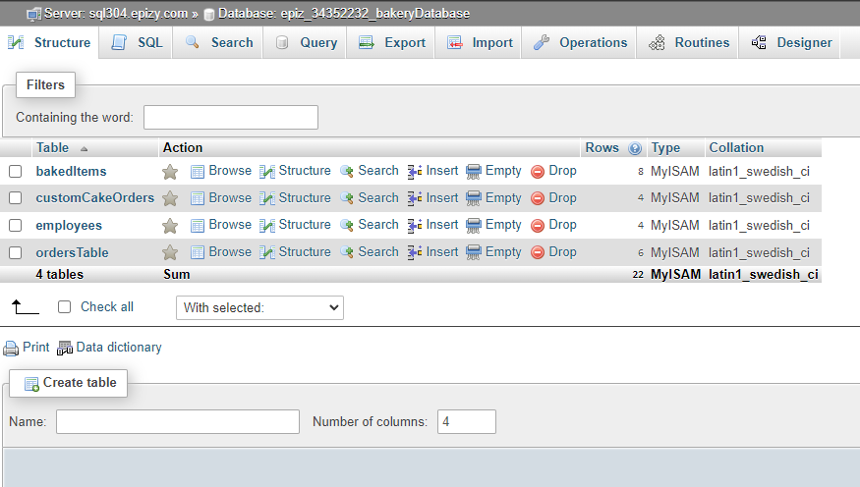

Here the admin is able to check the current orders and items. The admin can also update the values of these items.

# Products: Adding, removing, and updating products

**3.3.1 Adding and Removing Products**

New items can be added to the items database. New items can also be added to the home page, along with images for the product. New options for the custom cake orders can also be added.

**3.3.2 Updating Products**

Certain aspects of items are able to be changed. For example, the price of an item is able to be changed. To do so, you have to change the price value of the item that is stored in the website’s database. This a job for the admin to perform.

# The front page: adding and changing images

To add more images, extra code will have to be written. However, it only requires copying and pasting a block of code from the other pictures.

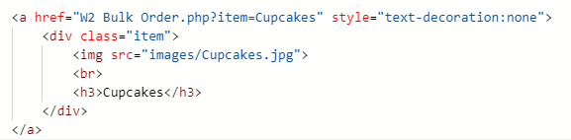

This block of code is what is used to display an image to the screen. Each image is displayed inside of a flex box, which is a dynamic CSS element which allows automatic resizing and aligning depending on the size of the screen.

# Orders

When a custom cake order or a bulk order is placed, the order is automatically added to the corresponding order table in the database. In the employees table, the current order ID will also be stored in the correct row per employee. Here, the employees can check which orders they have been assigned to. The current order ID will be removed upon order completion.

# Updating a page on your site

Any time a price is changed for an item, the price in the database can be easily updated to match its new cost. New images can also be added for existing products.

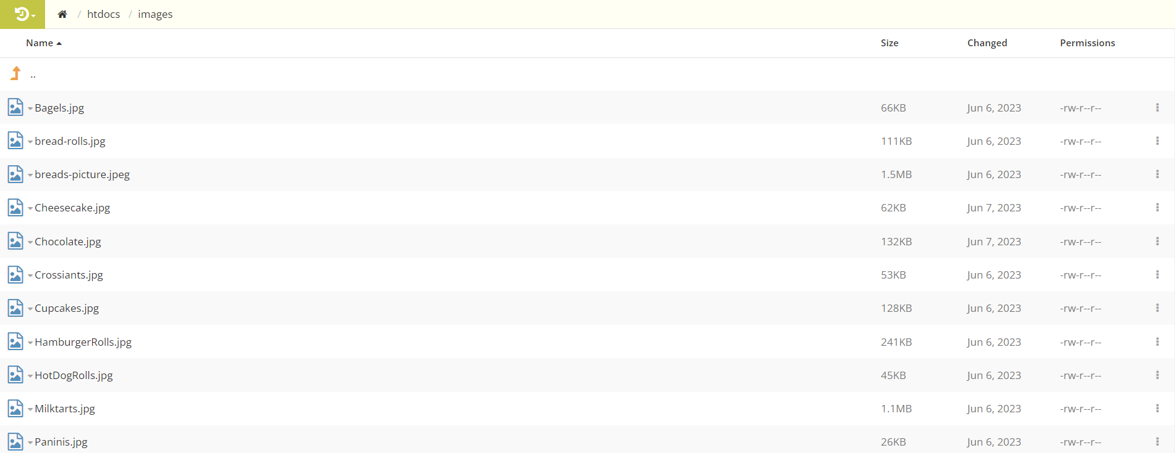

The new image must replace the old image and must be placed in the images folder, using the same name as the old image.